DFD – Solicitar candidato

aCapacidade 01

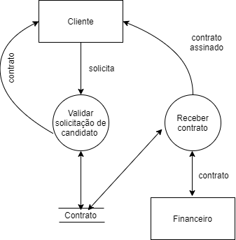

DFD – Receber candidato

Capacidade 02

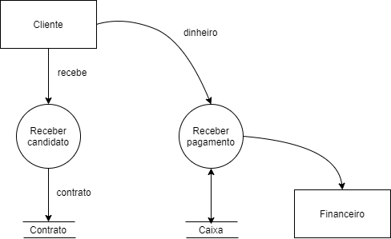

DFD – Cadastrar Vaga

Capacidade 03

%3CmxGraphModel%3E%3Croot%3E%3CmxCell%20id%3D%220%22%2F%3E%3CmxCell%20id%3D%221%22%20parent%3D%220%22%2F%3E%3CmxCell%20id%3D%222%22%20value%3D%22%22%20style%3D%22endArrow%3Dnone%3Bhtml%3D1%3B%22%20edge%3D%221%22%20parent%3D%221%22%3E%3CmxGeometry%20width%3D%2250%22%20height%3D%2250%22%20relative%3D%221%22%20as%3D%22geometry%22%3E%3CmxPoint%20x%3D%22260%22%20y%3D%22360%22%20as%3D%22sourcePoint%22%2F%3E%3CmxPoint%20x%3D%22340%22%20y%3D%22360%22%20as%3D%22targetPoint%22%2F%3E%3C%2FmxGeometry%3E%3C%2FmxCell%3E%3C%2Froot%3E%3C%2FmxGraphModel%3E

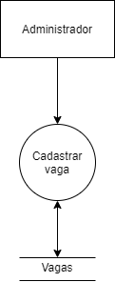

DFD – Cadastrar candidato

Capacidade 04

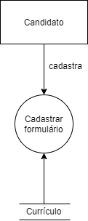

DFD – Buscar Vaga

Capacidade 05

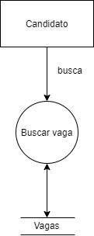

DFD – Cadastrar Testes

Capacidade 06

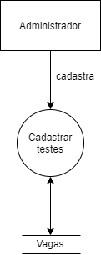

DFD – Gerar currículo

Capacidade 07

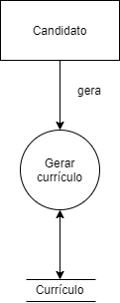

DFD – Gerar relatório

Capacidade 08

